|  |
| --- |
| Пензенский государственный университет  Факультет вычислительной техники  Кафедра «Вычислительная техника» |
| Отчет  по лабораторной работе №5  по дисциплине «Программирование на языке JAVA»  на тему «Многопоточность в Java»  Вариант № 2 |
|  |
|  |
| Выполнили: студенты группы 19ВВ3:  Субботкин М. В.  Ханбекова Е. В.  Проверила:  Юрова О. В. |
| Пенза  2022 |

Цель работы: научиться создавать многопоточные приложения c использованием стандартных средств языка Java.

Задание на лабораторную работу

Модифицировать приложение из предыдущей лабораторной работы, реализовав вычисление определенного интеграла в нескольких дополнительных потоках (число потоков определяется номером варианта), снимая нагрузку с основного потока и предотвращая "подвисание" графического интерфейса. Варианты с номерами до 5 включительно реализуют многопоточность путем наследования от класса Thread, остальные реализуют интерфейс Runnable.

Листинг программы:

package labjava1;

/*

* Click nbfs://nbhost/SystemFileSystem/Templates/Licenses/license-default.txt to change this license

* Click nbfs://nbhost/SystemFileSystem/Templates/GUIForms/JFrame.java to edit this template

*/

import javax.swing.table.DefaultTableModel;

import java.util.LinkedList;

import javax.swing.JOptionPane;

import javax.swing.JFileChooser;

import java.io.*;

/**

*

* @author Елена

*/

public class labjava1UI extends javax.swing.JFrame {

/**

* Creates new form labjava1UI

*/

public labjava1UI() {

initComponents();

}

/**

* This method is called from within the constructor to initialize the form.

* WARNING: Do NOT modify this code. The content of this method is always

* regenerated by the Form Editor.

*/

@SuppressWarnings("unchecked")

// <editor-fold defaultstate="collapsed" desc="Generated Code">

private void initComponents() {

jButton5 = new javax.swing.JButton();

jButton3 = new javax.swing.JButton();

jButton2 = new javax.swing.JButton();

jButton1 = new javax.swing.JButton();

jScrollPane1 = new javax.swing.JScrollPane();

jTable1 = new javax.swing.JTable();

jLabel3 = new javax.swing.JLabel();

jTextField3 = new javax.swing.JTextField();

jLabel2 = new javax.swing.JLabel();

jTextField2 = new javax.swing.JTextField();

jLabel1 = new javax.swing.JLabel();

jTextField1 = new javax.swing.JTextField();

jButton4 = new javax.swing.JButton();

jButton6 = new javax.swing.JButton();

jButton7 = new javax.swing.JButton();

jButton8 = new javax.swing.JButton();

jButton9 = new javax.swing.JButton();

jButton10 = new javax.swing.JButton();

jButton11 = new javax.swing.JButton();

setDefaultCloseOperation(javax.swing.WindowConstants.EXIT_ON_CLOSE);

setMaximumSize(new java.awt.Dimension(21474836, 2147483647));

jButton5.setText("Exit");

jButton5.addActionListener(new java.awt.event.ActionListener() {

public void actionPerformed(java.awt.event.ActionEvent evt) {

jButton5ActionPerformed(evt);

}

});

jButton3.setText("Clk");

jButton3.addActionListener(new java.awt.event.ActionListener() {

public void actionPerformed(java.awt.event.ActionEvent evt) {

jButton3ActionPerformed(evt);

}

});

jButton2.setText("Delete");

jButton2.addActionListener(new java.awt.event.ActionListener() {

public void actionPerformed(java.awt.event.ActionEvent evt) {

jButton2ActionPerformed(evt);

}

});

jButton1.setText("Set");

jButton1.addActionListener(new java.awt.event.ActionListener() {

public void actionPerformed(java.awt.event.ActionEvent evt) {

jButton1ActionPerformed(evt);

}

});

jTable1.setModel(new javax.swing.table.DefaultTableModel(

new Object [][] {

},

new String [] {

"Lower border", "Upper border", "Step ", "Integral"

}

) {

boolean[] canEdit = new boolean [] {

false, false, false, false

};

public boolean isCellEditable(int rowIndex, int columnIndex) {

return canEdit [columnIndex];

}

});

jScrollPane1.setViewportView(jTable1);

jLabel3.setText("Step");

jLabel2.setText("Lower border");

jTextField2.addActionListener(new java.awt.event.ActionListener() {

public void actionPerformed(java.awt.event.ActionEvent evt) {

jTextField2ActionPerformed(evt);

}

});

jLabel1.setText("Upper border");

jTextField1.addActionListener(new java.awt.event.ActionListener() {

public void actionPerformed(java.awt.event.ActionEvent evt) {

jTextField1ActionPerformed(evt);

}

});

jButton4.setText("FILL");

jButton4.addActionListener(new java.awt.event.ActionListener() {

public void actionPerformed(java.awt.event.ActionEvent evt) {

jButton4ActionPerformed(evt);

}

});

jButton6.setText("CLEAR");

jButton6.addActionListener(new java.awt.event.ActionListener() {

public void actionPerformed(java.awt.event.ActionEvent evt) {

jButton6ActionPerformed(evt);

}

});

jButton7.setText("CLEAR TABLE");

jButton7.addActionListener(new java.awt.event.ActionListener() {

public void actionPerformed(java.awt.event.ActionEvent evt) {

jButton7ActionPerformed(evt);

}

});

jButton8.setText("Save as text");

jButton8.addActionListener(new java.awt.event.ActionListener() {

public void actionPerformed(java.awt.event.ActionEvent evt) {

jButton8ActionPerformed(evt);

}

});

jButton9.setText("Load text file");

jButton9.addActionListener(new java.awt.event.ActionListener() {

public void actionPerformed(java.awt.event.ActionEvent evt) {

jButton9ActionPerformed(evt);

}

});

jButton10.setText("Save as bin");

jButton10.addActionListener(new java.awt.event.ActionListener() {

public void actionPerformed(java.awt.event.ActionEvent evt) {

jButton10ActionPerformed(evt);

}

});

jButton11.setText("Load bin file");

jButton11.addActionListener(new java.awt.event.ActionListener() {

public void actionPerformed(java.awt.event.ActionEvent evt) {

jButton11ActionPerformed(evt);

}

});

javax.swing.GroupLayout layout = new javax.swing.GroupLayout(getContentPane());

getContentPane().setLayout(layout);

layout.setHorizontalGroup(

layout.createParallelGroup(javax.swing.GroupLayout.Alignment.LEADING)

.addGroup(javax.swing.GroupLayout.Alignment.TRAILING, layout.createSequentialGroup()

.addContainerGap(javax.swing.GroupLayout.DEFAULT_SIZE, Short.MAX_VALUE)

.addGroup(layout.createParallelGroup(javax.swing.GroupLayout.Alignment.TRAILING)

.addGroup(layout.createSequentialGroup()

.addGroup(layout.createParallelGroup(javax.swing.GroupLayout.Alignment.LEADING)

.addComponent(jLabel3)

.addComponent(jLabel1)

.addComponent(jLabel2))

.addGap(34, 34, 34)

.addGroup(layout.createParallelGroup(javax.swing.GroupLayout.Alignment.LEADING)

.addComponent(jTextField2, javax.swing.GroupLayout.PREFERRED_SIZE, 78, javax.swing.GroupLayout.PREFERRED_SIZE)

.addComponent(jTextField1, javax.swing.GroupLayout.PREFERRED_SIZE, 78, javax.swing.GroupLayout.PREFERRED_SIZE)

.addComponent(jTextField3, javax.swing.GroupLayout.PREFERRED_SIZE, 78, javax.swing.GroupLayout.PREFERRED_SIZE))

.addGap(61, 61, 61)

.addGroup(layout.createParallelGroup(javax.swing.GroupLayout.Alignment.LEADING)

.addGroup(layout.createSequentialGroup()

.addGap(66, 66, 66)

.addComponent(jButton1, javax.swing.GroupLayout.PREFERRED_SIZE, 65, javax.swing.GroupLayout.PREFERRED_SIZE)

.addGap(18, 18, 18)

.addComponent(jButton2)

.addGap(18, 18, 18)

.addComponent(jButton3, javax.swing.GroupLayout.PREFERRED_SIZE, 65, javax.swing.GroupLayout.PREFERRED_SIZE))

.addComponent(jButton5, javax.swing.GroupLayout.Alignment.TRAILING, javax.swing.GroupLayout.PREFERRED_SIZE, 60, javax.swing.GroupLayout.PREFERRED_SIZE)))

.addComponent(jScrollPane1, javax.swing.GroupLayout.PREFERRED_SIZE, 471, javax.swing.GroupLayout.PREFERRED_SIZE))

.addGap(184, 184, 184))

.addGroup(layout.createSequentialGroup()

.addGroup(layout.createParallelGroup(javax.swing.GroupLayout.Alignment.LEADING, false)

.addGroup(layout.createSequentialGroup()

.addGap(173, 173, 173)

.addComponent(jButton4, javax.swing.GroupLayout.PREFERRED_SIZE, 64, javax.swing.GroupLayout.PREFERRED_SIZE)

.addGap(18, 18, 18)

.addComponent(jButton6)

.addGap(18, 18, 18)

.addComponent(jButton7))

.addGroup(layout.createSequentialGroup()

.addGap(143, 143, 143)

.addGroup(layout.createParallelGroup(javax.swing.GroupLayout.Alignment.LEADING, false)

.addComponent(jButton9, javax.swing.GroupLayout.DEFAULT_SIZE, javax.swing.GroupLayout.DEFAULT_SIZE, Short.MAX_VALUE)

.addComponent(jButton8, javax.swing.GroupLayout.DEFAULT_SIZE, javax.swing.GroupLayout.DEFAULT_SIZE, Short.MAX_VALUE))

.addPreferredGap(javax.swing.LayoutStyle.ComponentPlacement.RELATED, javax.swing.GroupLayout.DEFAULT_SIZE, Short.MAX_VALUE)

.addGroup(layout.createParallelGroup(javax.swing.GroupLayout.Alignment.LEADING, false)

.addComponent(jButton11, javax.swing.GroupLayout.DEFAULT_SIZE, javax.swing.GroupLayout.DEFAULT_SIZE, Short.MAX_VALUE)

.addComponent(jButton10, javax.swing.GroupLayout.DEFAULT_SIZE, javax.swing.GroupLayout.DEFAULT_SIZE, Short.MAX_VALUE))))

.addContainerGap(javax.swing.GroupLayout.DEFAULT_SIZE, Short.MAX_VALUE))

);

layout.setVerticalGroup(

layout.createParallelGroup(javax.swing.GroupLayout.Alignment.LEADING)

.addGroup(layout.createSequentialGroup()

.addGroup(layout.createParallelGroup(javax.swing.GroupLayout.Alignment.LEADING)

.addGroup(layout.createSequentialGroup()

.addGap(31, 31, 31)

.addGroup(layout.createParallelGroup(javax.swing.GroupLayout.Alignment.BASELINE)

.addComponent(jTextField1, javax.swing.GroupLayout.PREFERRED_SIZE, javax.swing.GroupLayout.DEFAULT_SIZE, javax.swing.GroupLayout.PREFERRED_SIZE)

.addComponent(jLabel2)))

.addGroup(layout.createSequentialGroup()

.addGap(39, 39, 39)

.addGroup(layout.createParallelGroup(javax.swing.GroupLayout.Alignment.BASELINE)

.addComponent(jButton1)

.addComponent(jButton2)

.addComponent(jButton3))))

.addPreferredGap(javax.swing.LayoutStyle.ComponentPlacement.RELATED)

.addGroup(layout.createParallelGroup(javax.swing.GroupLayout.Alignment.BASELINE)

.addComponent(jTextField2, javax.swing.GroupLayout.PREFERRED_SIZE, javax.swing.GroupLayout.DEFAULT_SIZE, javax.swing.GroupLayout.PREFERRED_SIZE)

.addComponent(jLabel1))

.addGap(18, 18, 18)

.addGroup(layout.createParallelGroup(javax.swing.GroupLayout.Alignment.BASELINE)

.addComponent(jLabel3)

.addComponent(jTextField3, javax.swing.GroupLayout.PREFERRED_SIZE, javax.swing.GroupLayout.DEFAULT_SIZE, javax.swing.GroupLayout.PREFERRED_SIZE)

.addComponent(jButton5))

.addGap(18, 18, 18)

.addComponent(jScrollPane1, javax.swing.GroupLayout.PREFERRED_SIZE, 102, javax.swing.GroupLayout.PREFERRED_SIZE)

.addGap(30, 30, 30)

.addGroup(layout.createParallelGroup(javax.swing.GroupLayout.Alignment.BASELINE)

.addComponent(jButton4)

.addComponent(jButton6)

.addComponent(jButton7))

.addGap(47, 47, 47)

.addGroup(layout.createParallelGroup(javax.swing.GroupLayout.Alignment.BASELINE)

.addComponent(jButton8)

.addComponent(jButton10))

.addGap(18, 18, 18)

.addGroup(layout.createParallelGroup(javax.swing.GroupLayout.Alignment.BASELINE)

.addComponent(jButton9)

.addComponent(jButton11))

.addContainerGap(80, Short.MAX_VALUE))

);

pack();

}// </editor-fold>

private void jButton5ActionPerformed(java.awt.event.ActionEvent evt) {

System.exit(0);

}

int middle = 0 ;

int row;

int rowCount;

int activeRow;

int activeRow1;

public class CulcThread1 extends Thread {

@Override

public void run(){

DefaultTableModel dt = (DefaultTableModel) jTable1.getModel();

for(activeRow = row; activeRow < middle ; activeRow++){

if(row != -1){

dt.setValueAt(integralList.get(activeRow).integralCalculate(), activeRow, 3);

System.out.println(Thread.currentThread().getName());

}

try {

Thread.sleep(1000);

}catch (InterruptedException e) {

System.out.println("Interrupt");

Thread.currentThread().interrupt();

throw new RuntimeException(e);

}

}

}

}

public class CulcThread2 extends Thread {

@Override

public void run(){

DefaultTableModel dt = (DefaultTableModel) jTable1.getModel();

for(activeRow1 = middle; activeRow1 < row + rowCount ; activeRow1++){

if(row != -1){

dt.setValueAt(integralList.get(activeRow1).integralCalculate(), activeRow1, 3);

System.out.println(Thread.currentThread().getName());

}

try {

Thread.sleep(1000);

}catch (InterruptedException e) {

System.out.println("Interrupt");

Thread.currentThread().interrupt();

throw new RuntimeException(e);

}

}

}

}

private void jButton3ActionPerformed(java.awt.event.ActionEvent evt) {

row = jTable1.getSelectedRow();

rowCount = jTable1.getSelectedRowCount();

CulcThread1 Thread1 = new CulcThread1();

CulcThread2 Thread2 = new CulcThread2();

if ( rowCount % 2 == 0){

middle = (row + rowCount)/2;

}else {middle = (row + rowCount)/2 + 1;}

Thread1.start();

Thread2.start();

}

public LinkedList<RecIntegral> integralList = new LinkedList<>();

private void jButton1ActionPerformed(java.awt.event.ActionEvent evt) {

DefaultTableModel tblModel = (DefaultTableModel) jTable1.getModel();

try {

String sa = jTextField1.getText();

String sb = jTextField2.getText();

String sc = jTextField3.getText();

if (sa.matches("[a-zA-Z]") | sb.matches("[a-zA-Z]") | sc.matches("[a-zA-Z]")) {

throw new MyExceptionClass("Data is not correct");

}

integralList.add(new RecIntegral(sa, sb, sc));

tblModel.addRow(new Object[]{jTextField1.getText(), jTextField2.getText(), jTextField3.getText()});

jTextField1.setText("");

jTextField2.setText("");

jTextField3.setText("");

} catch (MyExceptionClass e) {

JOptionPane.showMessageDialog(null, e);

}

}

private void jButton2ActionPerformed(java.awt.event.ActionEvent evt) {

int row = jTable1.getSelectedRow();

integralList.remove(row);

DefaultTableModel tblModel = (DefaultTableModel) jTable1.getModel();

tblModel.removeRow(jTable1.getSelectedRow());

}

private void jTextField2ActionPerformed(java.awt.event.ActionEvent evt) {

// TODO add your handling code here:

}

private void jTextField1ActionPerformed(java.awt.event.ActionEvent evt) {

// TODO add your handling code here:

}

private void jButton4ActionPerformed(java.awt.event.ActionEvent evt) {

// TODO add your handling code here:

DefaultTableModel tblModel = (DefaultTableModel) jTable1.getModel();

for (RecIntegral recInt : integralList) {

tblModel.addRow(new Object[]{recInt.getLow(), recInt.getHigh(), recInt.getStep()});

}

}

private void jButton6ActionPerformed(java.awt.event.ActionEvent evt) {

// TODO add your handling code here:

integralList.clear();

}

private void jButton7ActionPerformed(java.awt.event.ActionEvent evt) {

// TODO add your handling code here:

DefaultTableModel tblModel = (DefaultTableModel) jTable1.getModel();

while (tblModel.getRowCount() != 0) {

tblModel.removeRow(0);

}

}

private void jButton9ActionPerformed(java.awt.event.ActionEvent evt) {

String low;

String high;

String step;

DefaultTableModel tblModel = (DefaultTableModel) jTable1.getModel();

tblModel.setRowCount(0);

JFileChooser openInputFile = new JFileChooser();

int dlgWnd = openInputFile.showDialog(null, "Open txt file");

if (dlgWnd == JFileChooser.APPROVE_OPTION) {

File fileOpen = openInputFile.getSelectedFile();

try (FileReader readFile = new FileReader(fileOpen)) {

String buf;

BufferedReader rBuf = new BufferedReader(readFile);

while ((buf = rBuf.readLine()) != null) {

String[] v = buf.split(" ");

low = v[0];

high = v[1];

step = v[2];

try {

tblModel.addRow(new Object[]{low, high, step});

integralList.add(new RecIntegral(low, high, step));

} catch (MyExceptionClass e) {

JOptionPane.showMessageDialog(null, e);

}

}

} catch (IOException e) {

JOptionPane.showMessageDialog(null, e.getMessage());

}

}

}

private void jButton10ActionPerformed(java.awt.event.ActionEvent evt) {

JFileChooser openInputFile = new JFileChooser();

int dlgWnd = openInputFile.showDialog(null, "Save as bin file");

if(dlgWnd == JFileChooser.APPROVE_OPTION){

File fileOpen = openInputFile.getSelectedFile();

ObjectOutputStream listWrite = null;

try{

listWrite = new ObjectOutputStream(new BufferedOutputStream(new FileOutputStream(fileOpen)));

listWrite.writeObject(integralList);

}catch(IOException e){

e.printStackTrace();

}finally{

try{

listWrite.close();

}catch(IOException e){

e.printStackTrace();

}

}

}

}

private void jButton8ActionPerformed(java.awt.event.ActionEvent evt) {

JFileChooser openInputFile = new JFileChooser();

int dlgWnd = openInputFile.showDialog(null, "Save as txt file");

if (dlgWnd == JFileChooser.APPROVE_OPTION) {

File fileOpen = openInputFile.getSelectedFile();

try (FileWriter writeFile = new FileWriter(fileOpen, false)) {

integralList.forEach((s) -> {

RecIntegral rc = (RecIntegral) s;

try {

writeFile.write(String.valueOf(rc.getLow()) + " " + String.valueOf(rc.getHigh()) + " " + String.valueOf(rc.getStep()) + "\n");

} catch (IOException e) {

JOptionPane.showMessageDialog(null, e.getMessage());

}

});

} catch (IOException e) {

JOptionPane.showMessageDialog(null, e.getMessage());

}

}

}

private void jButton11ActionPerformed(java.awt.event.ActionEvent evt) {

DefaultTableModel tblModel = (DefaultTableModel) jTable1.getModel();

tblModel.setRowCount(0);

JFileChooser openInputFile = new JFileChooser();

int dlgWnd = openInputFile.showDialog(null, "Load bin file");

if (dlgWnd == JFileChooser.APPROVE_OPTION) {

File fileOpen = openInputFile.getSelectedFile();

ObjectInputStream listRead = null;

try {

listRead = new ObjectInputStream(new BufferedInputStream(new FileInputStream(fileOpen)));

integralList = (LinkedList) listRead.readObject();

} catch (IOException e) {

e.printStackTrace();

} catch (ClassNotFoundException classErr) {

JOptionPane.showMessageDialog(null, classErr.getMessage());

} finally {

try {

listRead.close();

} catch (IOException e) {

e.printStackTrace();

}

}

}

integralList.forEach((s) -> {

RecIntegral rc = (RecIntegral) s;

tblModel.addRow(new Object[]{rc.getLow(), rc.getHigh(), rc.getStep()});

});

}

/**

* @param args the command line arguments

*/

public static void main(String args[]) {

/* Set the Nimbus look and feel */

//<editor-fold defaultstate="collapsed" desc=" Look and feel setting code (optional) ">

/* If Nimbus (introduced in Java SE 6) is not available, stay with the default look and feel.

* For details see http://download.oracle.com/javase/tutorial/uiswing/lookandfeel/plaf.html

*/

try {

for (javax.swing.UIManager.LookAndFeelInfo info : javax.swing.UIManager.getInstalledLookAndFeels()) {

if ("Nimbus".equals(info.getName())) {

javax.swing.UIManager.setLookAndFeel(info.getClassName());

break;

}

}

} catch (ClassNotFoundException ex) {

java.util.logging.Logger.getLogger(labjava1UI.class.getName()).log(java.util.logging.Level.SEVERE, null, ex);

} catch (InstantiationException ex) {

java.util.logging.Logger.getLogger(labjava1UI.class.getName()).log(java.util.logging.Level.SEVERE, null, ex);

} catch (IllegalAccessException ex) {

java.util.logging.Logger.getLogger(labjava1UI.class.getName()).log(java.util.logging.Level.SEVERE, null, ex);

} catch (javax.swing.UnsupportedLookAndFeelException ex) {

java.util.logging.Logger.getLogger(labjava1UI.class.getName()).log(java.util.logging.Level.SEVERE, null, ex);

}

//</editor-fold>

/* Create and display the form */

java.awt.EventQueue.invokeLater(new Runnable() {

public void run() {

new labjava1UI().setVisible(true);

}

});

}

// Variables declaration - do not modify

private javax.swing.JButton jButton1;

private javax.swing.JButton jButton10;

private javax.swing.JButton jButton11;

private javax.swing.JButton jButton2;

private javax.swing.JButton jButton3;

private javax.swing.JButton jButton4;

private javax.swing.JButton jButton5;

private javax.swing.JButton jButton6;

private javax.swing.JButton jButton7;

private javax.swing.JButton jButton8;

private javax.swing.JButton jButton9;

private javax.swing.JLabel jLabel1;

private javax.swing.JLabel jLabel2;

private javax.swing.JLabel jLabel3;

private javax.swing.JScrollPane jScrollPane1;

private javax.swing.JTable jTable1;

private javax.swing.JTextField jTextField1;

private javax.swing.JTextField jTextField2;

private javax.swing.JTextField jTextField3;

// End of variables declaration

}

Результат работы программы:

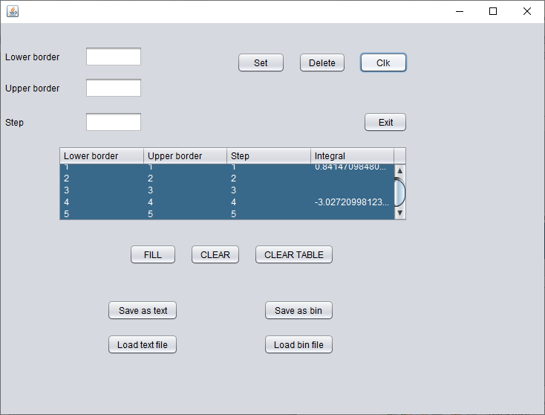

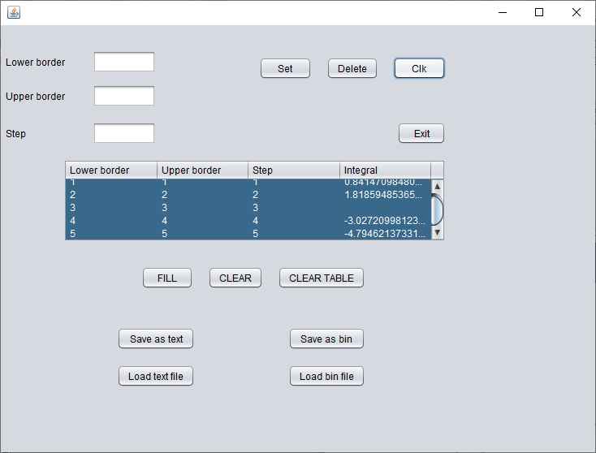

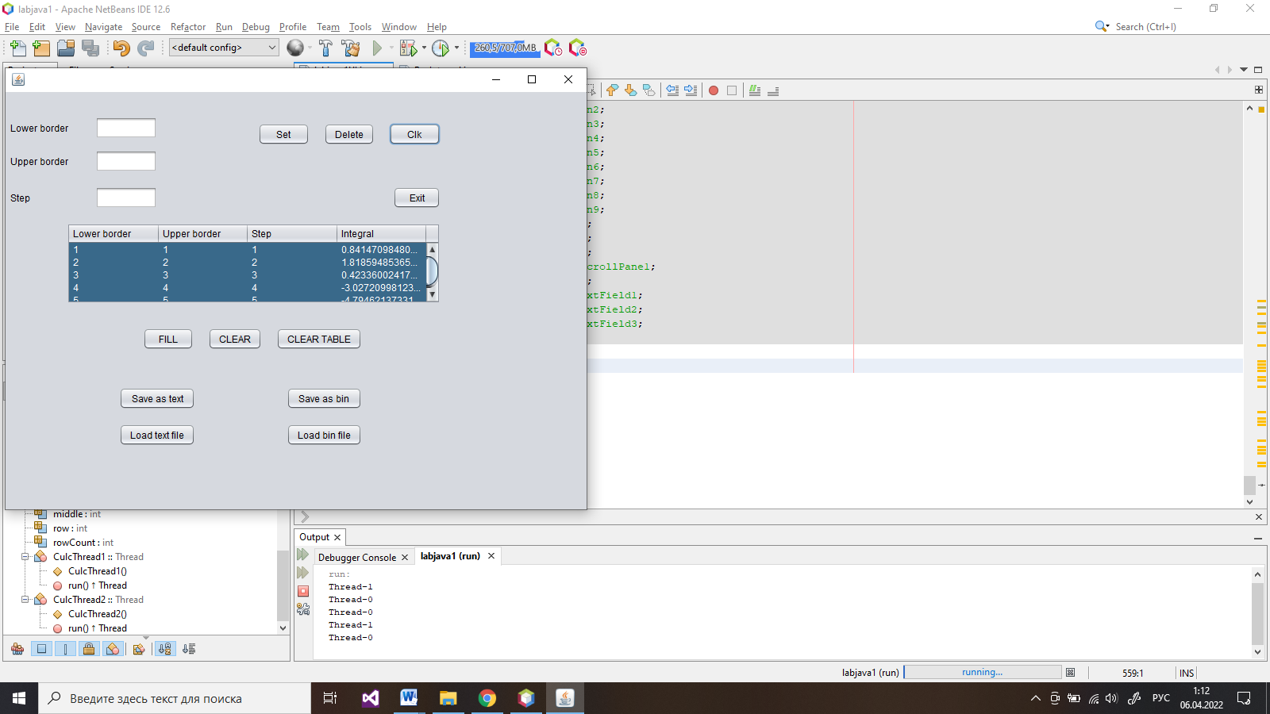

Вывод:

В ходе работы познакомились с реализацией многопоточности в Java и написали приложение, использующее 2 дополнительных потока.